Problem Statement: There can be multiple customers, who can place multiple orders on the site. Now a sales person can handle these orders will distribute into multiple sales persons (One order will be assign to one salesperson only). So a sales person can have multiple orders of multiple customers
- Create Database
-with the help of create database Sales I have created the database.
- Design Schema
- Schema for all tables were designed under the point of satisfaction of asked queries.
-3 tables created. sales_persons, order_records,customer.
- Create tables
-same with other 2 tables.
- Insert sample data
-insert into table values(), this command use for insertion the data.
- Find the sales person have multiple orders.
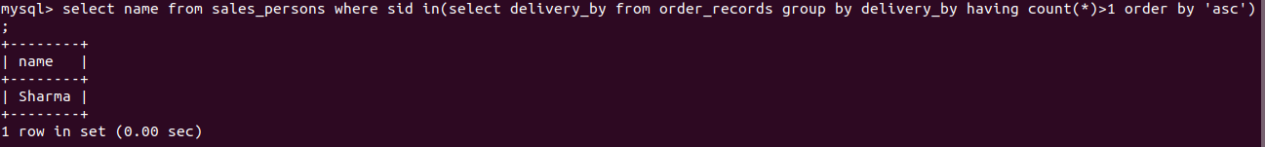
- Find the all sales person details along with order details
- joins not clear
- Create index
- How to show index on a table
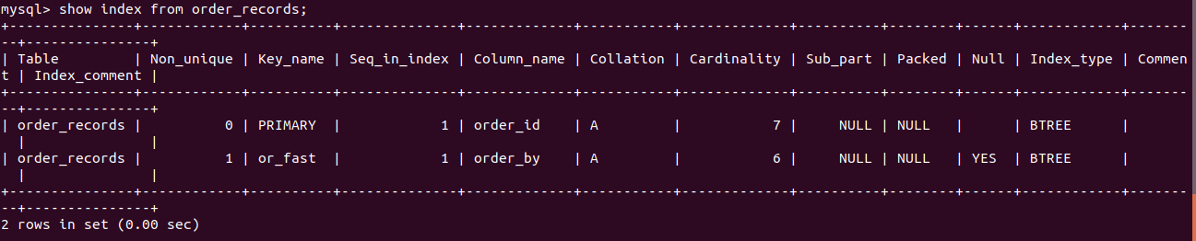
- Find the order number, sale person name, along with the customer to whom that order belongs to
- joins not clear

